Assignment No. 11 — Indexing and Query Optimization

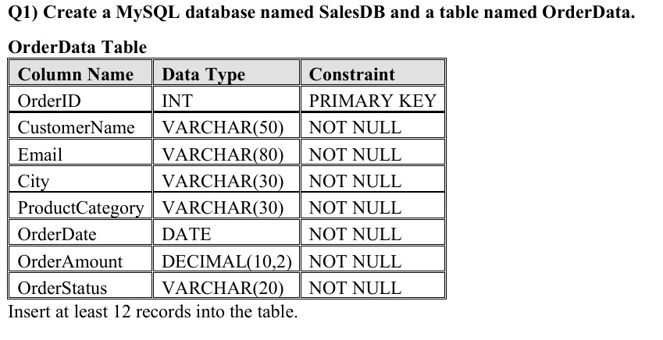
CREATE DATABASE SalesDB;

USE SalesDB;

CREATE TABLE OrderData (
OrderID INT PRIMARY KEY,
CustomerName VARCHAR(50) NOT NULL,
Email VARCHAR(80) NOT NULL,
City VARCHAR(30) NOT NULL,
ProductCategory VARCHAR(30) NOT NULL,
OrderDate DATE NOT NULL,
OrderAmount DECIMAL(10,2) NOT NULL,
OrderStatus VARCHAR(20) NOT NULL
);

INSERT INTO OrderData
(OrderID, CustomerName, Email, City, ProductCategory,
OrderDate, OrderAmount, OrderStatus)
VALUES
(1, 'Rahul Sharma', 'rahul@gmail.com', 'Mumbai',
'Electronics', '2026-01-05', 55000.00, 'Delivered'),
(2, 'Priya Patil', 'priya@gmail.com', 'Pune',
'Furniture', '2026-01-08', 32000.00, 'Delivered'),
(3, 'Aman Verma', 'aman@gmail.com', 'Nashik',
'Clothing', '2026-01-12', 8500.00, 'Pending'),
(4, 'Sneha Joshi', 'sneha@gmail.com', 'Mumbai',
'Electronics', '2026-01-20', 72000.00, 'Delivered'),
(5, 'Karan Mehta', 'karan@gmail.com', 'Thane',
'Furniture', '2026-02-03', 28000.00, 'Cancelled'),
(6, 'Neha Shah', 'neha@gmail.com', 'Pune',
'Electronics', '2026-02-08', 48000.00, 'Delivered'),
(7, 'Rohan Desai', 'rohan@gmail.com', 'Mumbai',
'Clothing', '2026-02-15', 12000.00, 'Pending'),
(8, 'Meera Kulkarni', 'meera@gmail.com', 'Nashik',
'Furniture', '2026-02-22', 36000.00, 'Delivered'), (9, 'Arjun Nair', 'arjun@gmail.com', 'Thane',
'Electronics', '2026-03-02', 64000.00, 'Shipped'),
(10, 'Divya More', 'divya@gmail.com', 'Mumbai', 'Furniture', '2026-03-07', 41000.00, 'Delivered'),
(11, 'Isha Singh', 'isha@gmail.com', 'Pune',
'Clothing', '2026-03-12', 15000.00, 'Shipped'), (12, 'Om Jadhav', 'om@gmail.com', 'Mumbai',
'Electronics', '2026-03-18', 59000.00, 'Pending');

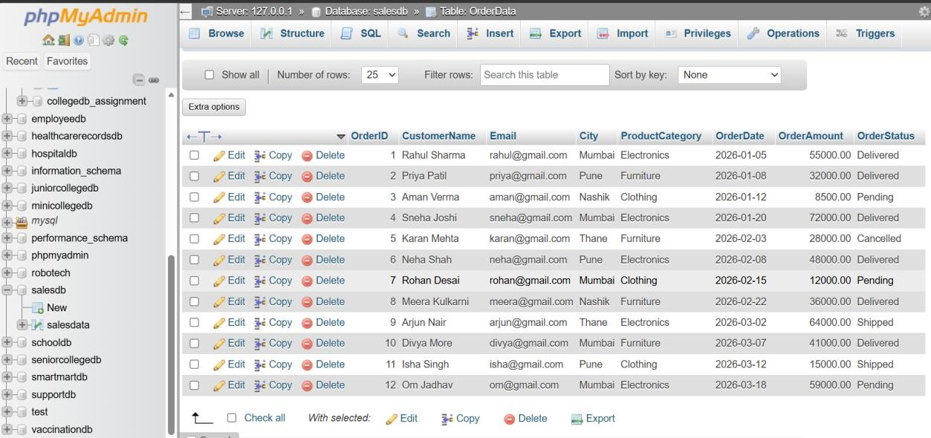
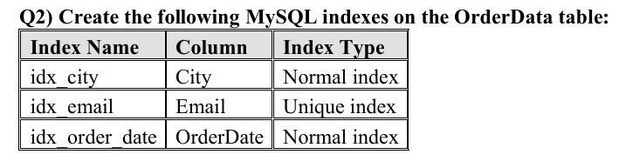
CREATE INDEX idx_city
ON OrderData(City);

CREATE UNIQUE INDEX idx_email
ON OrderData(Email);

CREATE INDEX idx_order_date
ON OrderData(OrderDate);

SHOW INDEX FROM OrderData;

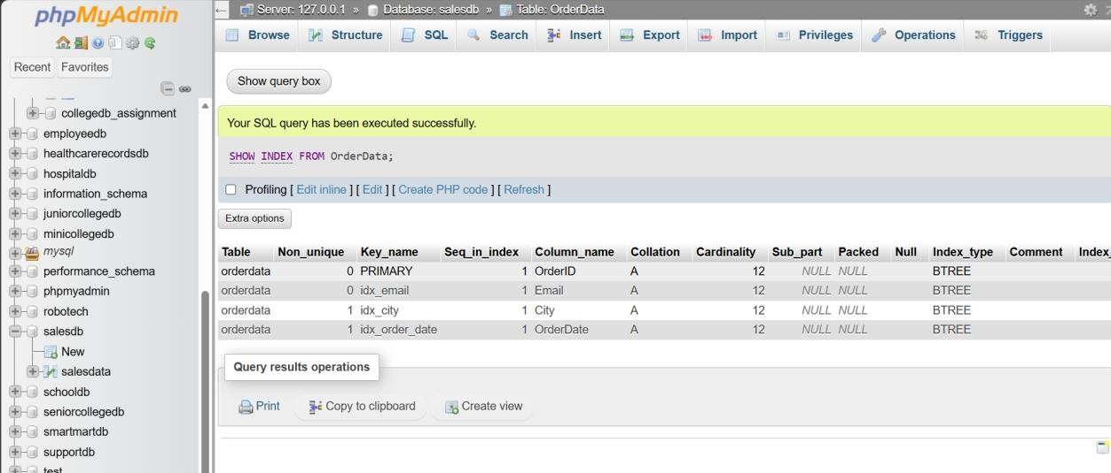

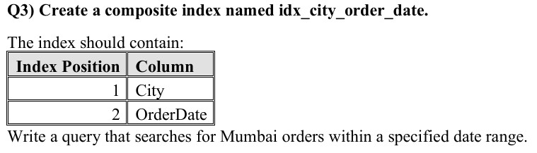

CREATE INDEX idx_city_order_date
ON OrderData(City, OrderDate);

SELECT *
FROM OrderData
WHERE City = 'Mumbai'
AND OrderDate BETWEEN '2026-02-01' AND '2026-03-31';

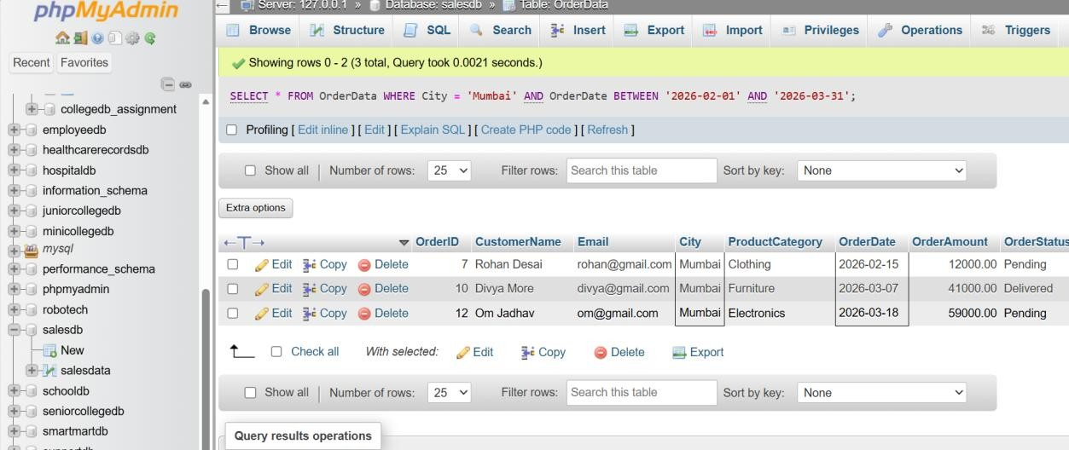

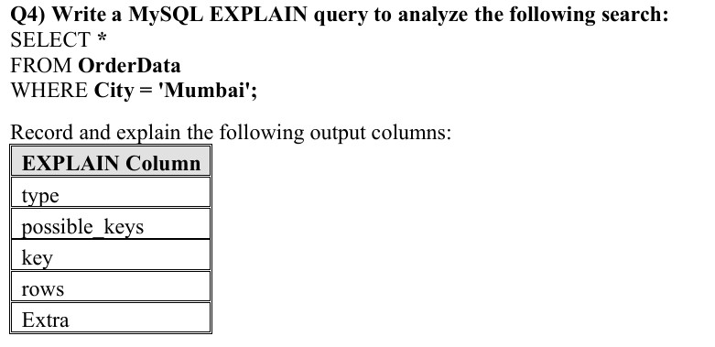

EXPLAIN
SELECT *
FROM OrderData
WHERE City = 'Mumbai';

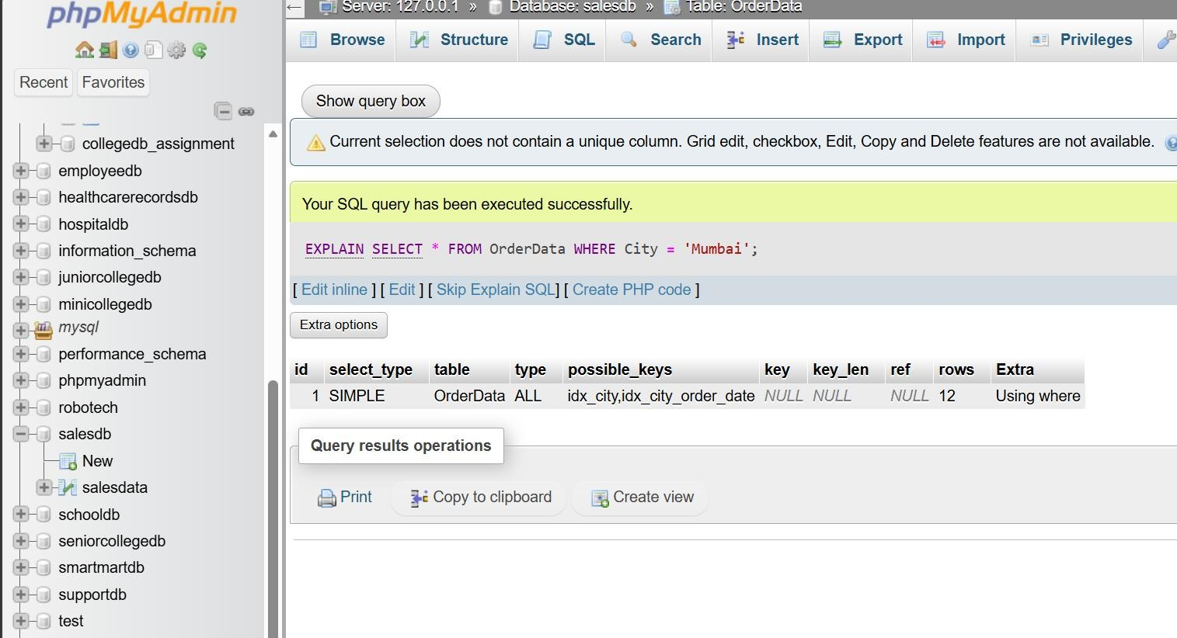

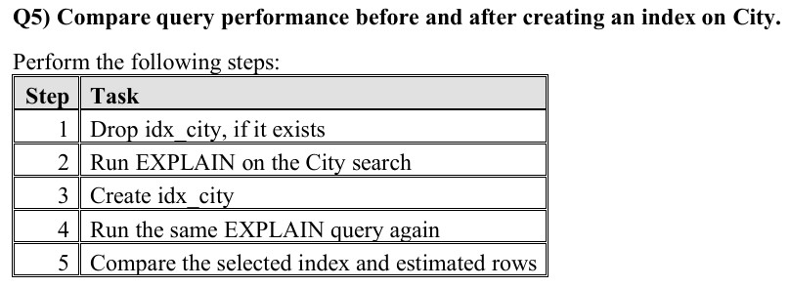

DROP INDEX idx_city
ON OrderData;

EXPLAIN
SELECT *
FROM OrderData
WHERE City = 'Mumbai';

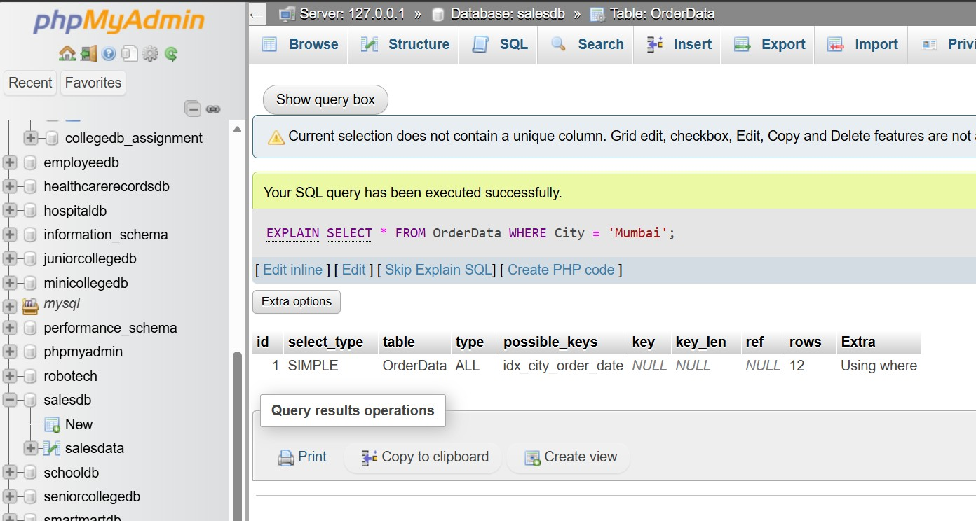
CREATE INDEX idx_city
ON OrderData(City);

EXPLAIN
SELECT *
FROM OrderData
WHERE City = 'Mumbai';

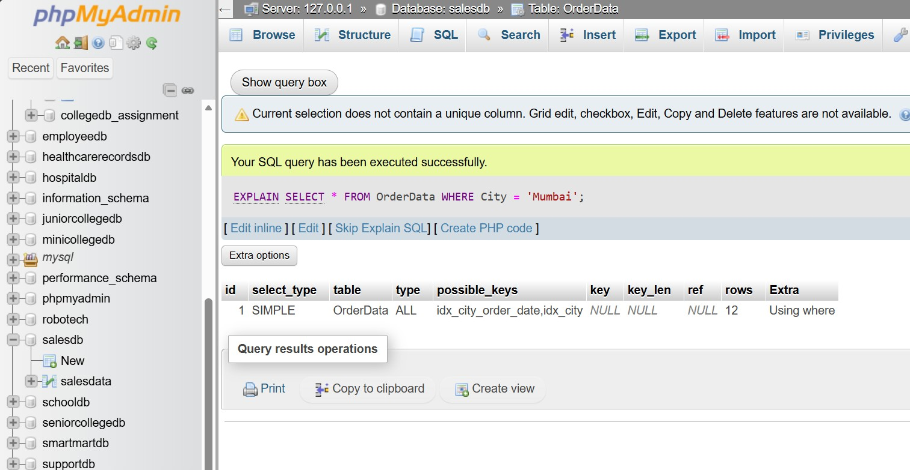
Before creating idx_city, the EXPLAIN output showed type = ALL, key = NULL, and an estimated 12 rows, indicating a full table scan. After creating idx_city, the index appeared in possible_keys, but the optimizer still selected key = NULL and estimated 12 rows. Therefore, for this small table, MySQL did not consider the new index beneficial enough to use.

Q6) Rewrite the following query in a more index-friendly form: SELECT * FROM OrderData WHERE YEAR(OrderDate) = 2026;

SELECT *
FROM OrderData
WHERE YEAR(OrderDate) = 2026;
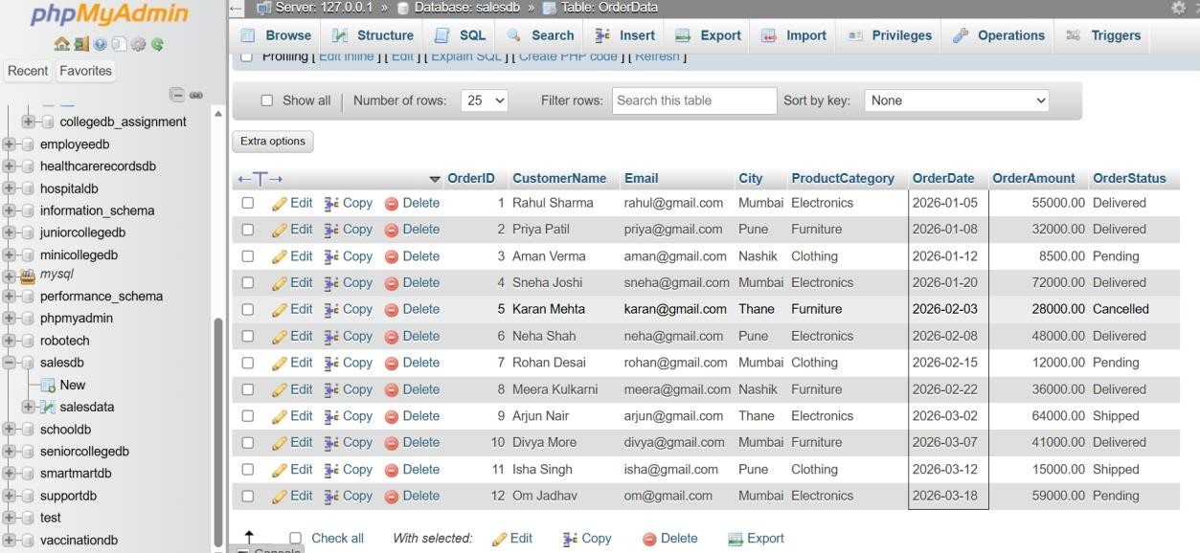

SELECT
OrderID,
CustomerName,
OrderDate,
OrderAmount
FROM OrderData
WHERE OrderDate >= '2026-01-01'
AND OrderDate < '2027-01-01';

